|  |  |  |  |  |
| --- | --- | --- | --- | --- |
| Image result for ZCOER | **ZEAL EDUCATION SOCIETY’S**  **ZEAL COLLEGE OF ENGINEERING AND RESEARCH**  **NARHE │PUNE -41 │ INDIA** | | | C:\Users\Admin\Downloads\Zeal 25 Years Logo.jpg |
|
|
| Record No.: **ZCOER-ACAD/R/42** | | Revision: **00** | Date:**17/06/2021** | |

**System Requirement Specifications**

**INTRODUCTION:**

Face recognition is an important application of Image processing owing to its use in many fields. Identification of individuals in an organization for the purpose of attendance is one such application of face recognition. Maintenance and monitoring of attendance records plays a vital role in the analysis of performance of any organization. The purpose of developing attendance management system is to computerize the traditional way of taking attendance. Automated Attendance Management System performs the daily activities of attendance marking and analysis with reduced human intervention. The prevalent techniques and methodologies for detecting and recognizing face fail to overcome issues such as scaling, pose, illumination, variations, rotation, and occlusions. The proposed system aims to overcome the pitfalls of the existing systems and provides features such as detection of faces, extraction of the features, detection of extracted features, and analysis of students' attendance. The system integrates techniques such as image contrasts, integral images, color features and cascading classifier for feature detection. The system provides an increased accuracy due to use of a large number of features (Shape, Colour, LBP, wavelet, Auto-Correlation) of the face. Faces are recognized using Euclidean distance and k-nearest neighbor algorithms. Better accuracy is attained in results as the system takes into account the changes that occur in the face over the period of time and employs suitable learning algorithms.

The system is tested for various use cases. We consider a specific area such as classroom attendance for the purpose of testing the accuracy of the system. The metric considered is the percentage of the recognized faces per total number of tested faces of the same person. The system is tested under varying lighting conditions, various facial expressions, presence of partial faces (in densely populated classrooms) and presence or absence of beard and spectacles. An increased accuracy (nearly 100%) is obtained in most of the cases considered.

**OBJECTIVES:**

The objectives of the project are given below:

1. Detection of unique face image amidst the other natural components such as walls, backgrounds etc.

1. Extraction of unique characteristic features of a face useful for face recognition.
2. Detection of faces amongst other face characters such as beard, spectacles etc.
3. Effective recognition of unique faces in a crowd(individual recognition in crowd).
4. Automated update in the database without human intervention.

**METHODOLOGY:**

In this proposed system, the system is instantiated by the mobile .After it triggers then the system starts processing the image for which we want to mark the attendance. Image Capturing phase is one in which we capture the image. This is basic phase from which we start initializing our system. We capture an image from a camera which is predominantly checked for certain constraints like lightning, spacing, density, facial expressions. The captured image is resolute for our requirements. Once it is resolute we make sure it is either in png or jpeg format else it is converted. We take individuals different frontal postures so that the accuracy can be attained to the maximum extent. This is the training database in which every individual has been classified based on labels. For the captured image, from an every object we detect only frontal faces from viola-jones algorithm which detects only the frontal face posture of an every individual from the captured image. This detects only faces and removes every other parts since we are exploring the features of only faces. These detected faces are stored in the test database for further enquiry. Features are extracted in this extraction phase. The detected bounding boxes are further queried to look for features extraction and the extracted features are stored in matrix. For every detected phase this feature extraction is done. Features we look here are Shape, Edge, Color, Wavelet, Auto-Correlation and LBP. Face is recognized once we completed extracting features. The feature which is already trained with every individual is compared with the detected faces feature and if both features match then it is recognised. Once, it recognizes it is going to update in the student attendance database. Once, the process is completed the testing images gets deleted since, we are trying to design it for both the accuracy as well as efficiency co-efficient.

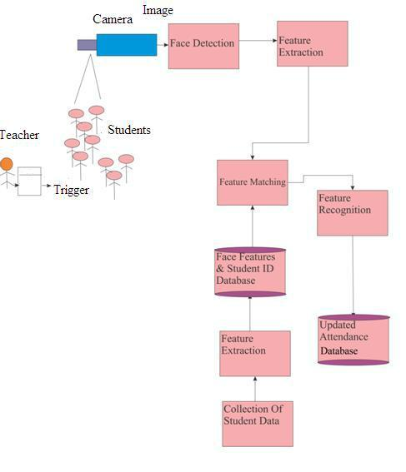

Fig 1 System Model

**Experimental Results**

|  |  |  |  |  |  |
| --- | --- | --- | --- | --- | --- |
| Test | Image/person | Number of | Total | Total | Accuracy |
| case |  | people | Images | Testing |  |
|  |  |  |  | Images |  |
| Case 1 | 10 | 3 | 30 | 10 | 100% |
| Case 2 | 5 | 2 | 10 | 8 | 100% |
| Case 3 | 2 | 7 | 14 | 5 | 83% |
| Case 4 | 1 | 3 | 3 | 5 | 100% |
| Case 5 | 3 | 20 | 60 | 5 | 100% |
| Case 6 | 2 | 2 | 4 | 6 | 100% |
| Case 7 | 3 | 4 | 12 | 15 | 76% |
| Case 8 | 2 | 10 | 20 | 5 | 72% |
| Case 9 | 1 | 10 | 10 | 5 | 64% |
| Case | 1 | 2 | 2 | 2 | 43% |
| 10 |  |  |  |  |  |

**Statistics**

1. **Sensitivity:**measures the proportion of actual positives which are correctly identified assuch. Here the condition is we have 100 non-defective tomato images and 85 images satisfy this condition.

Sensitivity = TP / ( TP + FN) = 20/(20+0) = 1

1. **Specificity:**measures the proportion of negatives which are correctly identified as such.[Specificity](http://en.wikipedia.org/wiki/Sensitivity_and_specificity) = TN / ( TN + FP )= 20/(20+0) = 1
2. **Accuracy:** measurementsystem is the degree of closeness of measurements of

a quantity to that quantity's actual (true) value. Accuracy = (sensitivity+specificity)/2 = (1+1)/2 =1*100=100%

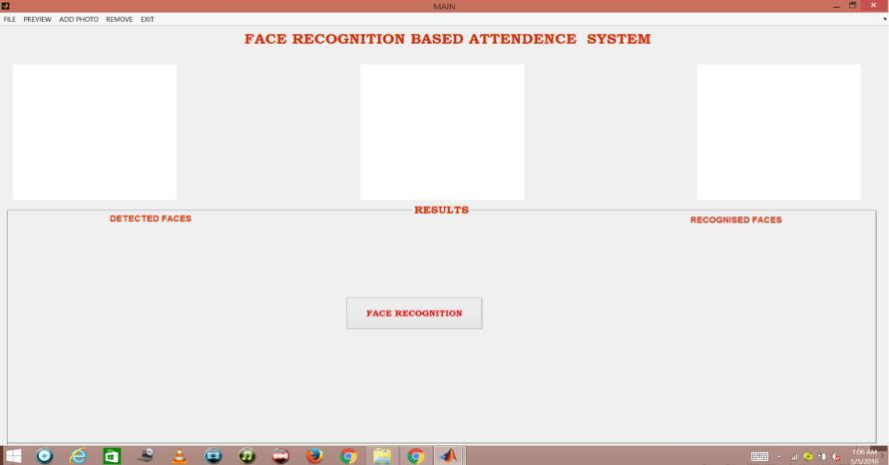

Fig 2 Graphical User Interface

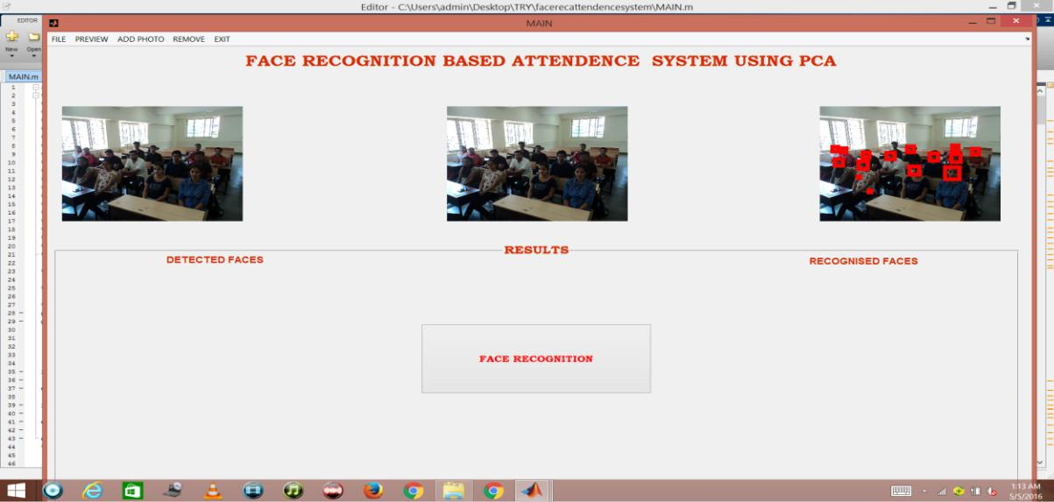

Fig 3 Face Detection

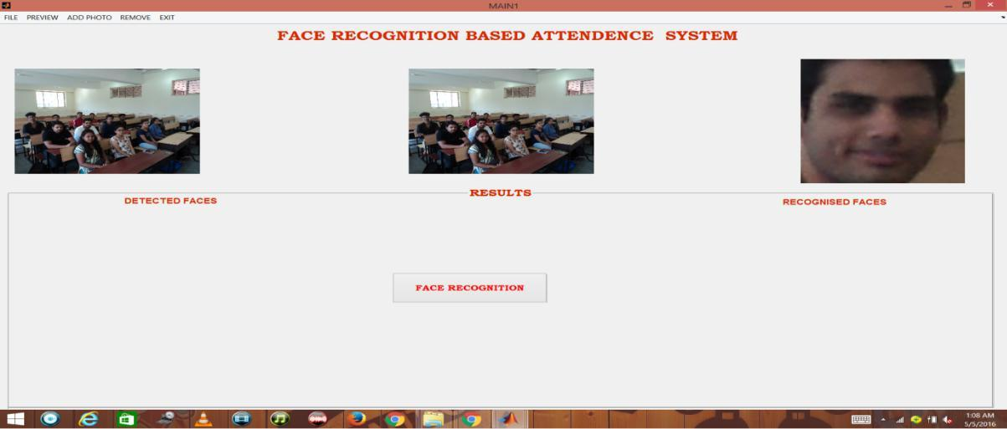

Fig 4 Face Recognition

The classroom image is processed to distinguish only the faces from the other objects present. Face Detection is carried out and each face is bounded by a bounding box as shown in the fig 3. The faces are recognized from the detected faces as shown in the fig 4. Each recognized face appears in GUI one after the other. The system is tested for various constraints, one of which is faces with and without beard**.** The system has attained 100% accuracy in detecting such faces.Once the images are recognized, attendance for the corresponding student is updated in the excel sheet as shown in fig 5.



Fig 5 Updation in excel sheet

**CONCLUSION:**

There may be various types of lighting conditions, seating arrangements and environments in various classrooms. Most of these conditions have been tested on the system and system has shown 100% accuracy for most of the cases. There may also exist students portraying various facial expressions, varying hair styles, beard, spectacles etc. All of these cases are considered and tested to obtain a high level of accuracy and efficiency. Thus, it can be concluded from the above discussion that a reliable, secure, fast and an efficient system has been developed replacing a manual and unreliable system. This system can be implemented for better results regarding the management of attendance and leaves. The system will save time, reduce the amount of work the administration has to do and will replace the stationery material with electronic apparatus and reduces the amount of human resource required for the purpose. Hence a system with expected results has been developed but there is still some room for improvement

**SCOPE FOR FUTURE WORK:**

1. Currently, the system has reached the accuracy level up to 80% for partial and dense images. It can further be improved to obtain higher accuracy levels.
2. Further, 2 or more IP cameras can be employed and each image can be processed separately. The results of these can be merged to obtain better results and accuracy in denser classrooms.